1. ENTITY RELATIONSHIP DIAGRAM:

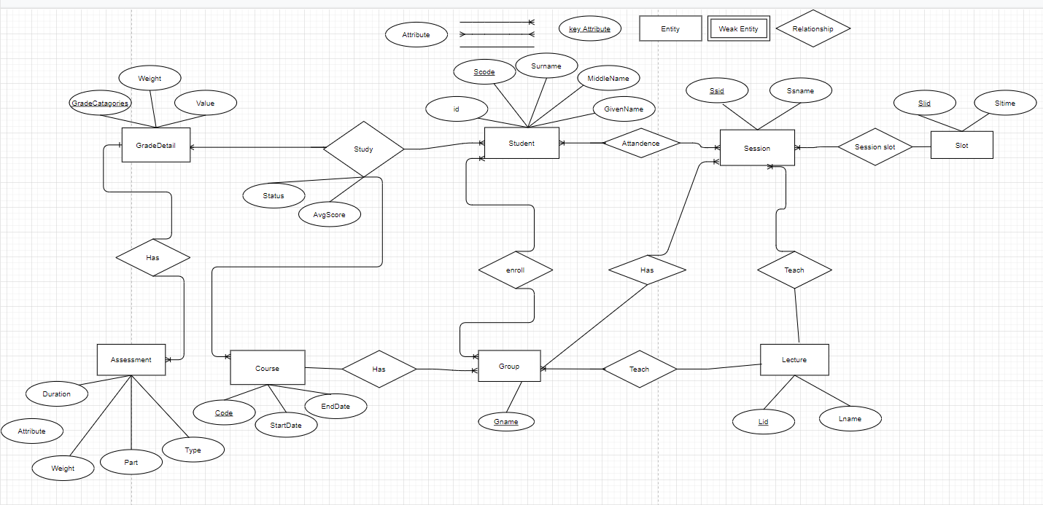

1. DESCRIPTION OF THE DATABASE:

DESCRIBE THE PROBLEM Point System Management:

Entities with their attributes:

1. GradeDetail
2. Assessment
3. Study
4. Course
5. Student
6. Group
7. Session
8. Lecture
9. Slot

* A student has a relationship enrolling with group and type is many-to-many and attendance together in one session of each course so the relationship between Student and Lesson is many-to-many.
* Group student can study many subjects, but a study group can only participate in the study once of the respective subject.
* Each student studying each course has a GradeDetail so the relationship between Course and Student is many-to-many.
* Each subject has many assessment points, but each assessment score can only be applied to one corresponding assessment.
* Each GradeDetail has many assessments so the relationship between them is one-to-many.

1. RELATIONAL SCHEMA

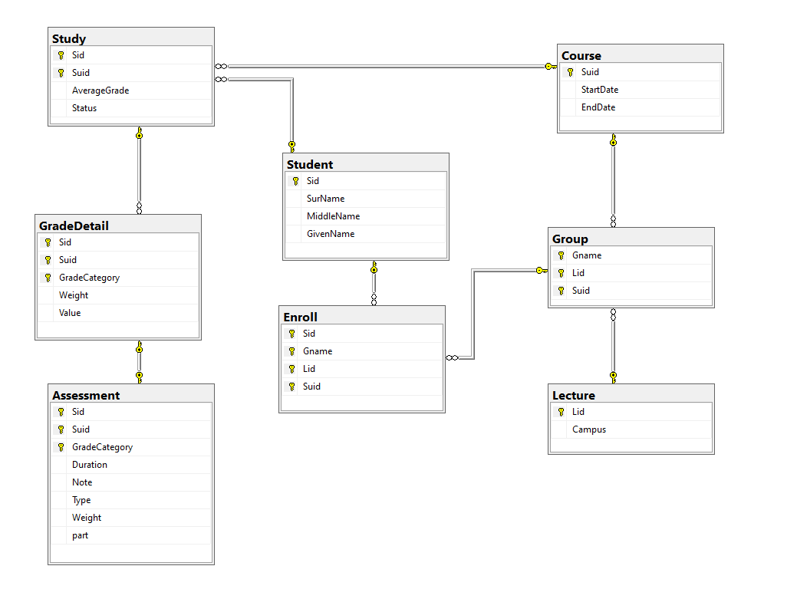

1. THE SET OF DATABASE STATEMENTS USED TO CREATE THE TABLES

create table Student(

[Sid] varchar(10) primary key,

SurName varchar(10),

MiddleName varchar(10),

GivenName varchar(10),

)

create table Lecture(

Lid varchar(10) primary key,

Campus varchar(10)

)

create table Course(

Suid varchar(10) primary key,

StartDate date,

EndDate date

)

create table Enroll(

[Sid] varchar(10),

Gname varchar(10),

Lid varchar(10),

Suid varchar(10),

Primary key (Gname,[Sid],Lid,Suid),

foreign key (Gname,Lid,Suid) references [Group](Gname,Lid,Suid),

foreign key ([Sid]) references Student([Sid]),

)

create table [Group](

Gname varchar(10),

Lid varchar(10),

Suid varchar(10),

primary key (Gname,Lid,Suid),

foreign key (Lid) references Lecture(Lid),

foreign key (Suid) references Course(Suid),

)

create table Study(

[Sid] varchar(10),

Suid varchar(10),

AverageGrade float,

[Status] int,

Primary key (Suid,[Sid]),

foreign key (Suid) references Course(Suid),

foreign key ([Sid]) references Student([Sid]),

)

create table GradeDetail(

[Sid] varchar(10),

Suid varchar(10),

GradeCategory varchar(20),

[Weight] int,

[Value] float,

Primary key (Suid,[Sid],GradeCategory),

foreign key (Suid,[Sid]) references Study(Suid,[Sid]),

check ([Weight]>0 and [Weight]<100),

check ([Value]>0 and [Value]<10)

)

create table Assessment(

[Sid] varchar(10),

Suid varchar(10),

GradeCategory varchar(20),

Duration varchar(20),

Note varchar(500),

[Type] varchar(10),

[Weight] int,

part int,

Primary key (Suid,[Sid],GradeCategory),

foreign key (Suid,[Sid],GradeCategory) references GradeDetail(Suid,[Sid],GradeCategory),

check ([Weight]>0 and [Weight]<100)

)